1. **JavaScript Outputs**

Js output is a set of ways used to appear (display) js statements.

These ways are:

1. Writing into an alert box, using window.alert().
2. Writing into the HTML output using document.write().
3. Writing into the HTML output using  window.id.value
4. Writing into an HTML element, using innerHTML.
5. Writing into the browser console, using console.log().

**Output ways:**

In Java script any name followed by pair of parenthesis is identified as a **method** or a **function.**

* **window.alert(js data);**

This way is used to display java script data in an alert box. You can skip window keyword as this: alert(js data);

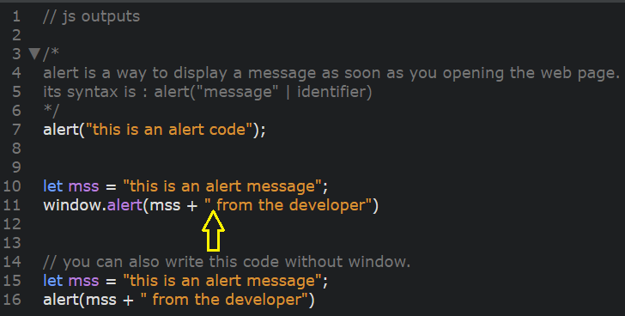

* **document.write(argument);**

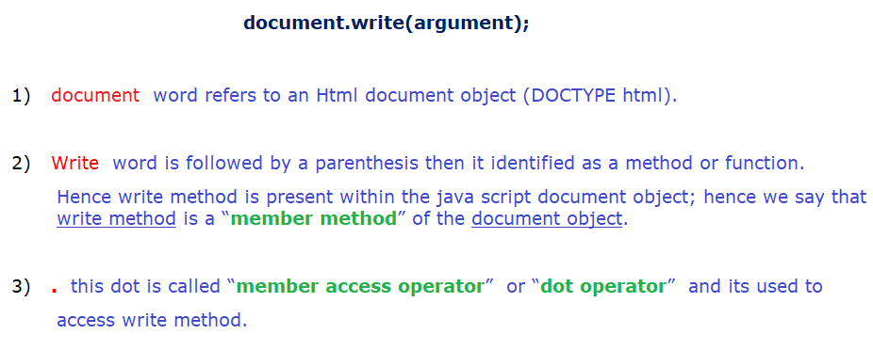

Document.write method/function is used to **display** some content in the browser window.

This content is called “**argument**” or “**parameter**” it may be:

* 1. single expression (argument)
  2. multiply expressions (arguments)

**Ex:**

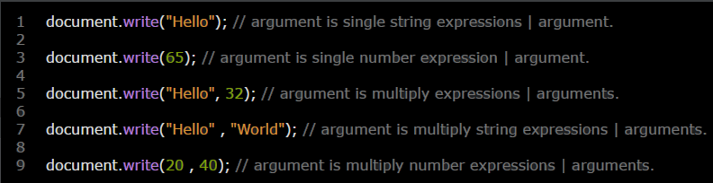

**Note:** This way is a suitable for testing js code because if you use it after an HTML document is loaded, it will delete all existing data in your page.

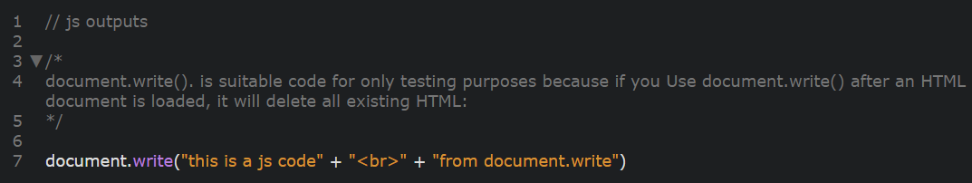

* **innerHTML = js data**

This way is used to add or change the **content** (content = js data) of a specific HTML element.

It has the next syntax: document.getElementById(“Id”).innerHTML = js data

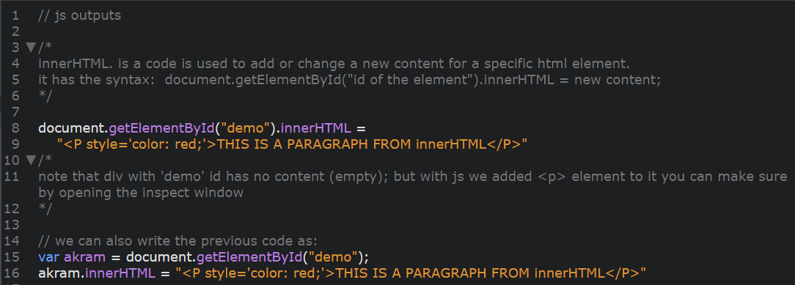

* **window.id.value = js data**

This way is used to change the **value** of an editable HTML element (like: inputs)

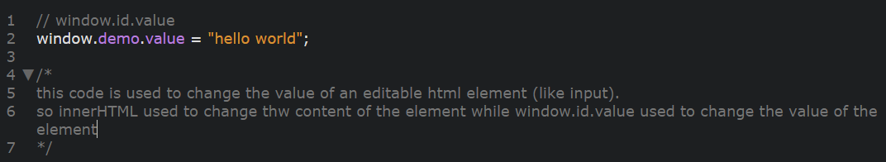

So if you want to change:

* + HTML content use innerHTML
  + HTML value use window.id.value
* **console.log(js data)**

This way is used to appear js data only on the console “not in the client-side”

